Service Desk Knowledge Base Features

Feature Summary

As of version 1.20 the following features are available:

Architecture

- Based on SQL 2005
- Simple English language queries
- Strict keyword queries
- Developed in PHP language.
- Self Maintaining
- Very scalable, low system resources
- Online product updates. Automated installation of new updates.

Authentication

- NT Domain authentication (no local passwords required)
- Or Local account/password authentication.

Security

- Group based permissions model, users can have Read, Write or approval privilege in one or more groups.
- Articles for groups for which a user is not a member are completely hidden.
- Public group allows the option to have articles available for all users.
- Guest mode allows option of having non-authenticated users able to access Public articles.
- Articles initially entered have a status of Pending Approval and are hidden from all users except for the author of the article plus persons that have approval permission for the Article group.

Article Entry

- Articles content can be enter in one of three modes:
  - Using built in Rich HTML editor
  - Pressing import Content button to automatically import word/mht files that are then stored internally in the database as HTML format.
  - Using the “Attachment as Content” feature which uploads the original MS Word or PDF document and displays it with in a frame when reading/searching the article.
- Article versioning. Ability to set number of versions of the article to save. With ability to view or restore previous versions.
- Articles can be classified by, Group, Product and Types.
- Unlimited number of attachments can be attached to each article.

Article Searching

- Like a Google search, simple English or Strict text searching.
- Most relevant articles are returned first.
- Ability to sort results.
- Short cuts can be saved to search results.
- Searching searches attachments to articles as well, such as .doc, xls, .pdf file types.

Article Notification

- Users can enable Email notification when articles for their group(s) are modified.
- Email notifications for modification of an article that you had submitted.

Bulletin Board System

- Includes a Bulletin (info board) system which contains important temporary notices that are displayed on the Home Page.
- Allows for all support staff to enter an alert or notification of some event or outage that all users can read.

Ease of Use

- Browsing of articles by products, types etc.
- Online help
- Users profiles/settings, allows features such as Email notifications, query types.
- Unlimited attachments maybe added to articles.
- One article maybe set related to another article.

Customizable

- Many settings can be configured to suite local requirements (see settings under Installation Guide below).

Reporting

- Article Hit counters (also add weight to article ranking)
- Real time reporting, searches vs hits per day
- Detailed reporting, details of every search made and hits returned
- Records who/when read each article

Screen Shots

Display of default home page layout

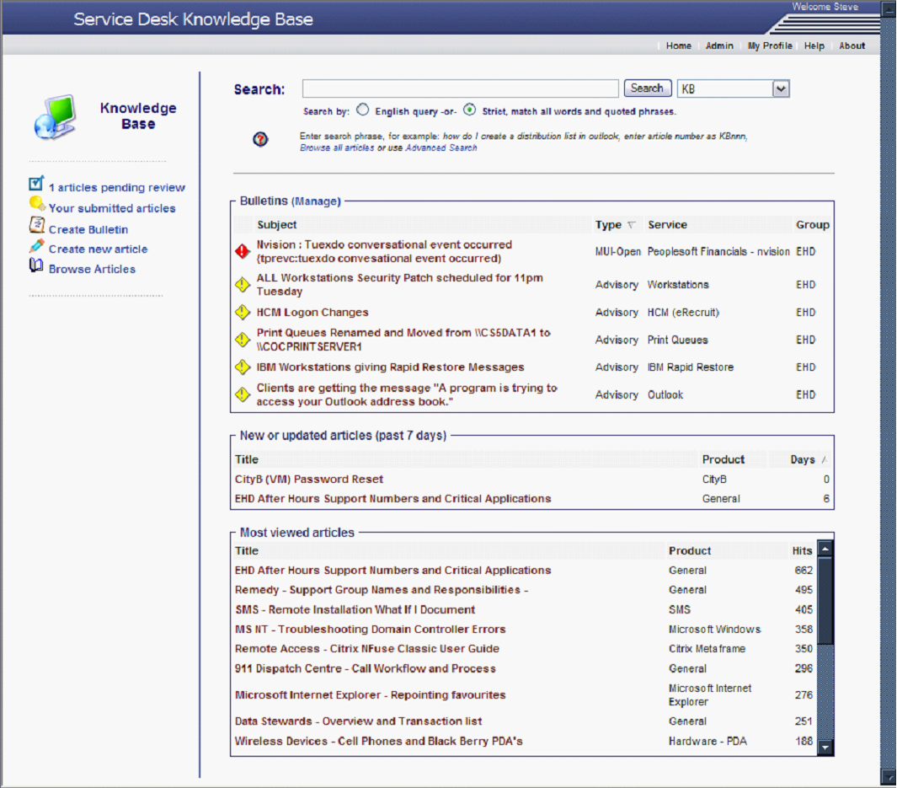

Display of Article Editor page

The details tab provides the classification and attachment controls, Content tab provides the article editor (shown below), the versions tab provides list of archived versions of the articles and the Audit tab includes details of all changes made to the article.

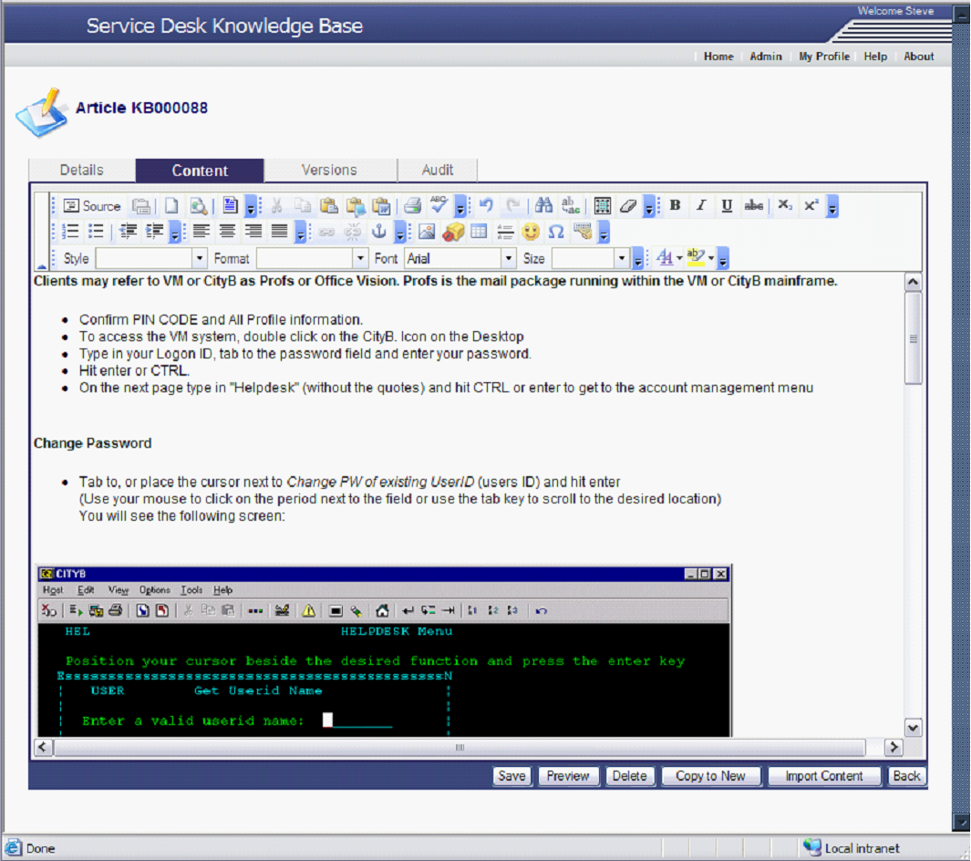
Display of Administration page

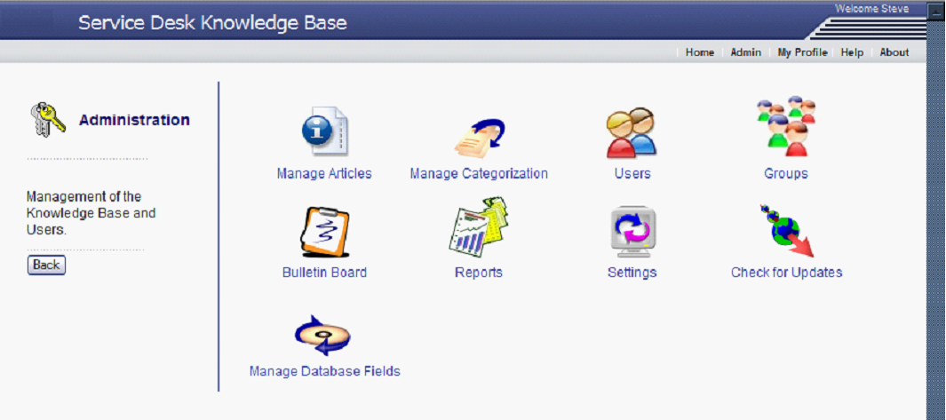

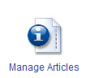 | Manage Articles, by searching based on date criteria, contact information etc. Also provides ability to perform bulk modifications.
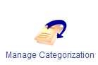 | Define the Categorization methods, types, etc.
 | Define/modify groups.
 | Administer bulletin board messages, search, modify delete etc.
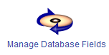 | Manage database schema allows adding fields, setting hover over help, keys etc. (Currently read only)
 | Report menu, displays list of available reports, for example, Active articles, KB Usage, Recent searches, Bulletin reports.
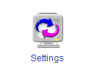 | Set application name and many other settings. See below for more information.
 | Checks for updates available for product. If available a description of the update is display and ability to automatically upgrade.

Display of “Browse” feature which displays left tree of articles grouped by Product or Type.
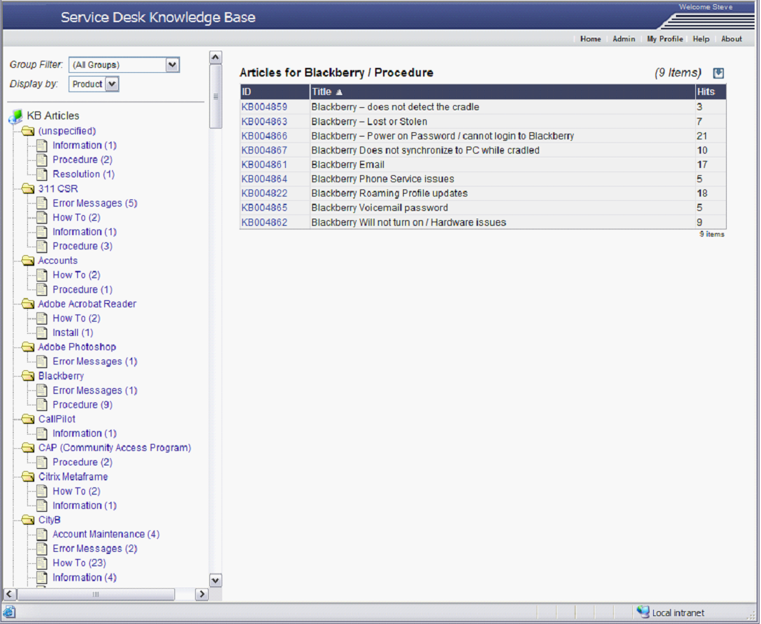

Display of Recent Searches report
Click on item to zoom into displaying what articles were read by user as a result of search. 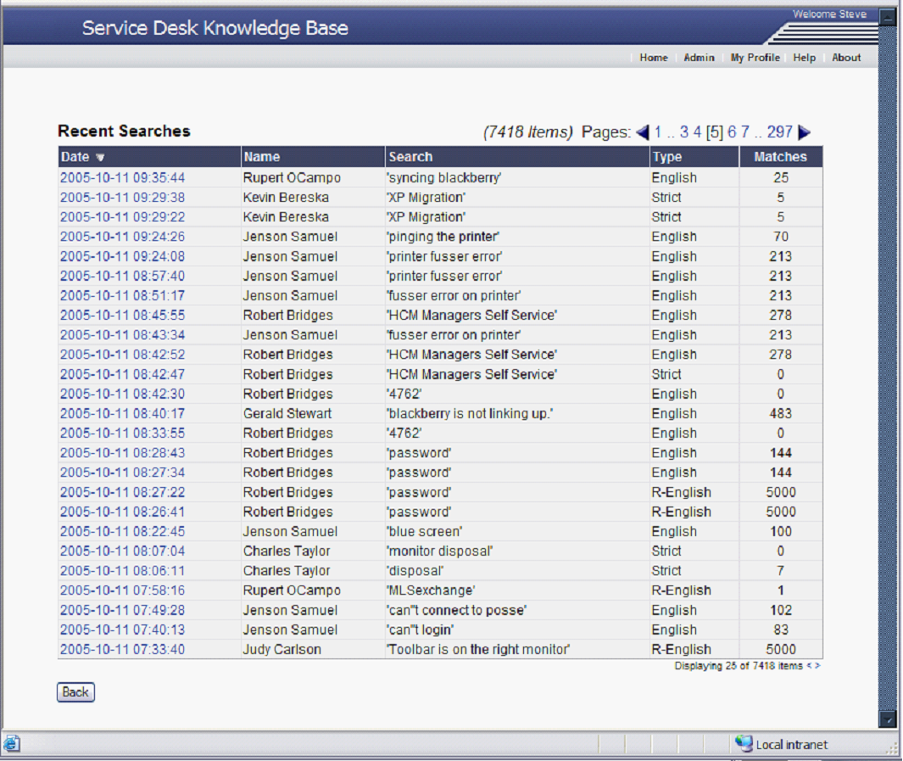

Provides a visual indication of number of searches vs number of hits. Using this information along with report above, you can determine what articles are needed to satisfy the demand.

